# Big Data Analytics

# Practical 4

# 22BCE501

# HDFS Command



mkdir

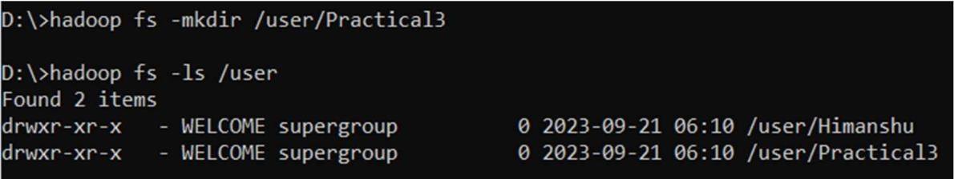

ls

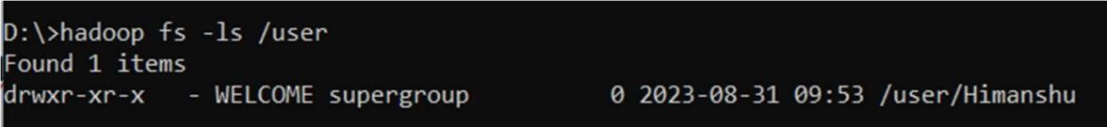

rmdir



rm



copyFromLocal

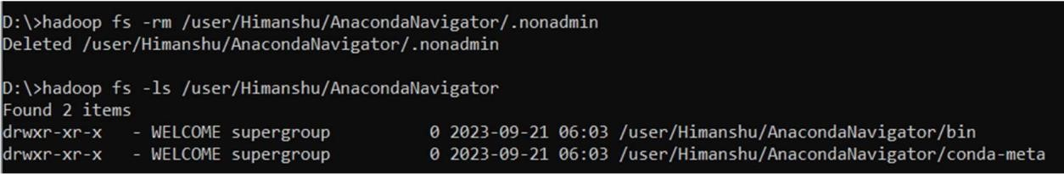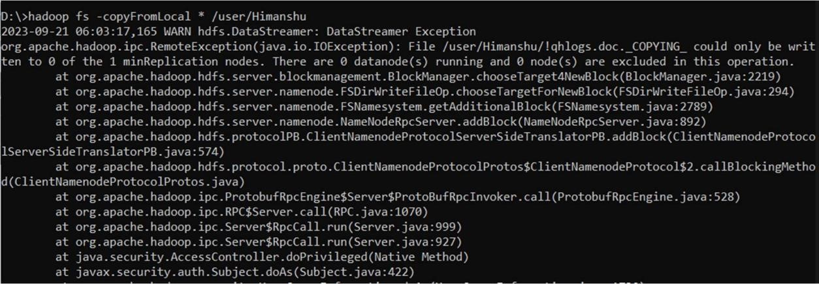

copyToLocal



count



cp



help



find



expunge



mv

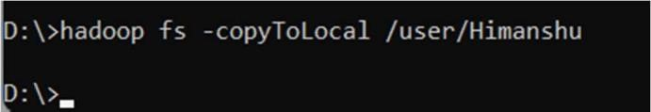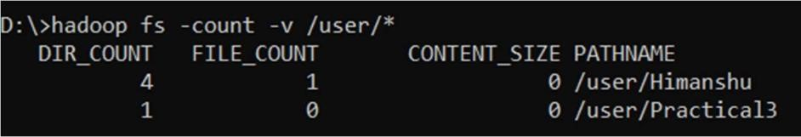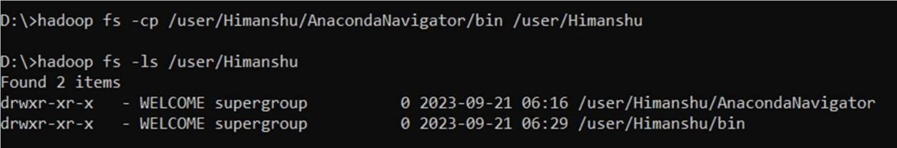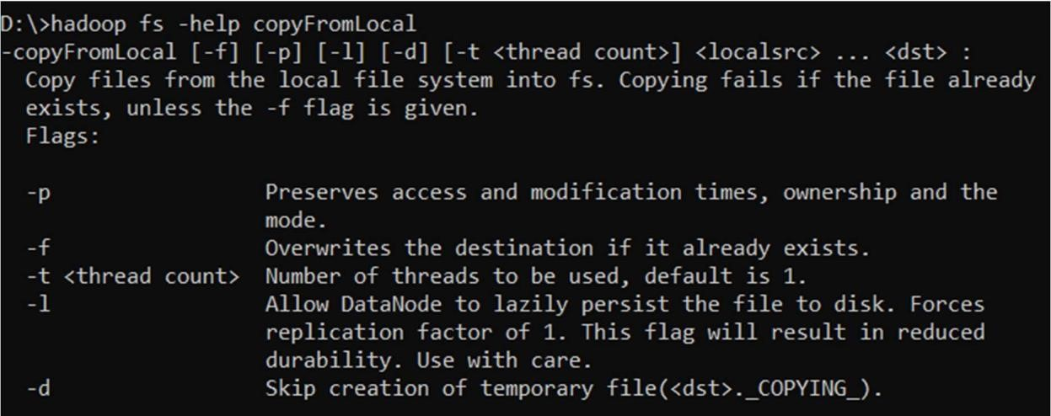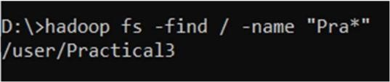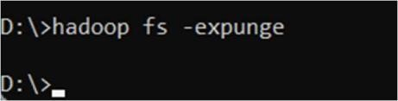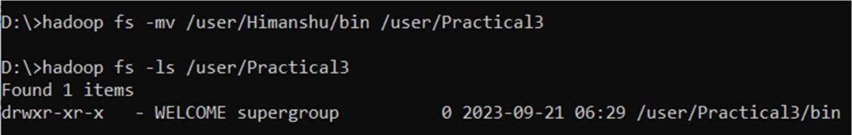

stat



chmod



usage



touchz

